A MANIFESTO FOR THE 21ST CENTURY

We, of the Harrison Studio, believe
As do others, although differently
That a series of events have come into being
Beginning in the time of Gilgamesh and before
Beginning with agriculture and the first genetic manipulation
Beginning with culture of animals and ongoing genetic manipulation
Beginning with globalization six thousand years ago with the Salt Route
A little later, the Silk Route
And later and later…
Especially with science informed by Descartes’ clock
And with modernity recreating the cultural landscape
And deconstructing nature thereby
From the Industrial Revolution to the present
Until all at once a new force has become apparent
We reframe a legal meaning ecologically
And name it the Force Majeure

We, of the Harrison Studio assert
As do others somewhat differently
That the Force Majeure, framed ecologically
Enacts in physical terms outcomes on the ground
Everything we have created in the global landscape
Bringing together the conditions that have accelerated global warming
Acting in concert
With the massive industrial processes of extraction, production and consumption
That have subtracted forests and depleted top soil
Profoundly reduced ocean productivity
While creating a vast chemical outpouring into the atmosphere
Onto the lands and within the waters
That altogether comprise this Force Majeure

We, of the Harrison studio, are grateful
For the opportunity to join in this perilous conversation
Where the discourse in general
Is about time, money, power, justice, sex, politics
Personal well-being and survival
In many combinations and re-combinations
Attending somewhat to social injustice
And somewhat less to ecosystems’ injustice

This discourse points to human consciousness
Every day continuously attending to itself
With little attention paid to that which is not itself
Leading to intrinsic value switched for extrinsic value
With human creativity generating technologies
That appear not to like that which are not themselves
Sometimes becoming the reverse of their original intention

There is modest conversation drifting toward green
As industry and people think about doing well by doing good
Good being green roofs green cars
Green manufacturing processes
Green transformation of material
Green production of all kinds
expanding green markets
Green in everyday life
in the frame of sustainability

We, of the Harrison Studio, assert
As do others, as yet, not many
That in the face of multiple tipping points
Passed and near passed
From CO2/methane to nitrates/nitrites
And more and more
All of these efforts and all of this work
Altruistic from the best of people
Greedy and mean spirited from the worst of people
Is better to be doing than not to be doing
But on balance, insufficient
Endlessly insufficient

The Force Majeure, so obvious, even in the now
Is generating ocean rise
Forcing the ocean’s food chains to simplify
Compelling glaciers and snow pack to melt
Creating flood and drought at continental scale
Which is the outcome for rivers
As they flow down through Asia from the Tibetan Plateau
And true for many parts of the Americas

The outcomes for the Peninsula of Europe are unfortunate
The numbers have been crunched
Revealing the trajectory of drought predicted to proceed
From Portugal to the southern parts of Germany and beyond
Reducing 2.4 million square kilometers of farmland
That now feeds over 450 million Europeans by almost a third within 50 years
The population will grow the food supply will shrink
The waters will rise
People will need to move upward
The rich will continue to do well
Not true for the middle class
And devastating for the poor

We, of the Harrison Studio conclude
That a counter force is available
But unless put in place well within the next fifty years
Civil society in many places will experience perturbation then collapse
Keeping company with the ecosystems
experiencing perturbation and simplification

A counterforce that is comprised of understandings
Waiting to be internalized and then enacted
They are

First understanding
Nature’s economic system stores the energy that it does not immediately need
mostly in carbon formations
Second understanding
Nature does not charge a profit as do culture’s economic systems
Third understanding
All natural systems are dissipative structures with individuals that form them living,
reproducing then dying with indeterminacy as a norm
Fourth understanding
All natural systems have learned to nest within each other, and, within a context of
symbiosis contribute to collective systems survival, sometimes with abundance
Fifth understanding
Human constructed artifacts particularly legal, political, economic as well as
production and consumption systems seek constancy but are often in violation of the
laws of conservation of energy pointing toward systems entropy

When the first four understandings are internalized and integrated into all parts of the fifth understating. A transformation can happen that will open pathways for human created systems to yield autonomy and accept limitations. An acceptance that will permit the formation of processes of nesting within nesting that will enable nature’s ways of invention and human ways of invention presently so oppositional to co-join.

The counterforce we envision will permit
A culturally generated acceleration of adaptation behaviors at great scale
Operating at a parallel rate to the climate forcing generated by human activity
setting the stage for adapting strategies that will assist the migration of our own species
And those who are not ourselves
Who are co-equally endangered by the threat of mass extinction
Into zones of greater safety
Tuning to and over time in concert with the Force Majeure

Images reflecting Force Majeure Work

From Peninsula Europe Part III
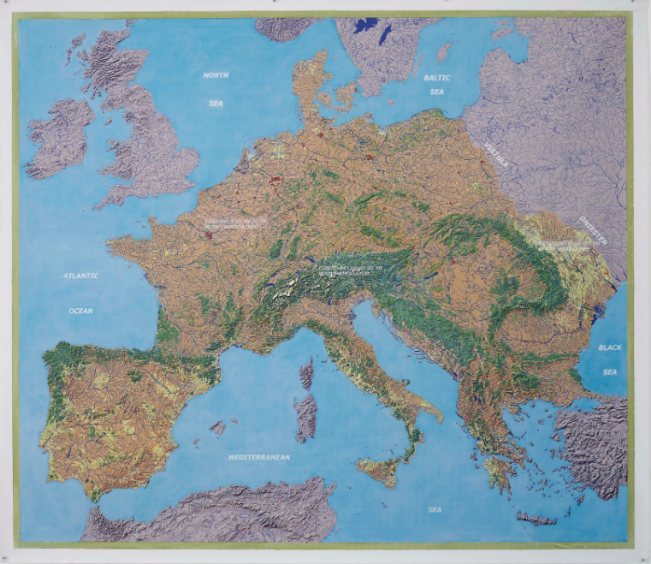
Imagine the research is right How will the twenty republics
drought moves across Europe six kingdoms and one duchy
the temperature continues to rise that are the European Union
glacial melt continues accelerating surrender enough autonomy
river flow becomes intermittent surrender closely held powers
flooding increases from sudden rains to create collectively
The half-million sq km the new form of governance
of mostly monocultural high ground forest that is able to meet
succumbs in the main to drought and disease a force majeure of this magnitude

From Peninsula Europe Part III
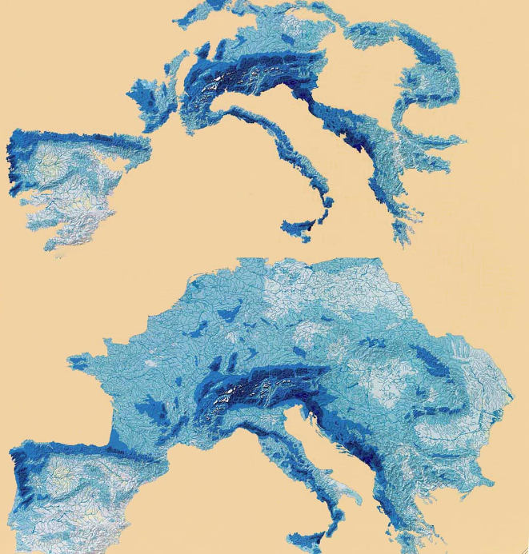
The Harrison Studio Experiment

The decision is taken to reject the Alpine treeline definition of the high ground instead locating where rivers begin to define the high ground discovering that rivers begin mostly at 1200 feet and above. Lifting the shape off of the map, we discover an area of 1.46 million sq km at the 1200 feet level that if rehabilitated according to the concept of the upward movement of species will dramatically reduce the impact of the predicted temperature raise, flood and drought. We suggest a water tax to fund work on the ground.

From Peninsula Europe Part III
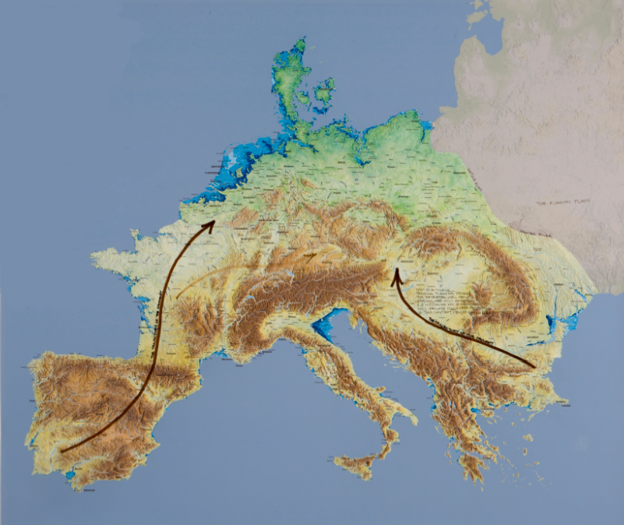
The prediction of drought moving from Portugal to mid Germany and beyond has the following associated consequences:
- One third of 2.3 million sq km of farming becomes minimally productive.
- 1/3 of 340 thousand sq km of meadowlands become minimally productive.
- Most of the 560,000 sq km of high ground forest succumbs to insect disease, drought and fire.
- The outcome to civil society if business as usual practice continues is unfortunate in the extreme. We predict food rationing at best. At the worst, perturbation and collapse of society as we know it.

Tibet is the High Ground: Part III, 2009- A Force Majeure work
An Ecologically Based Proposal for the Tibetan Plateau (or Qingzang Plateau)
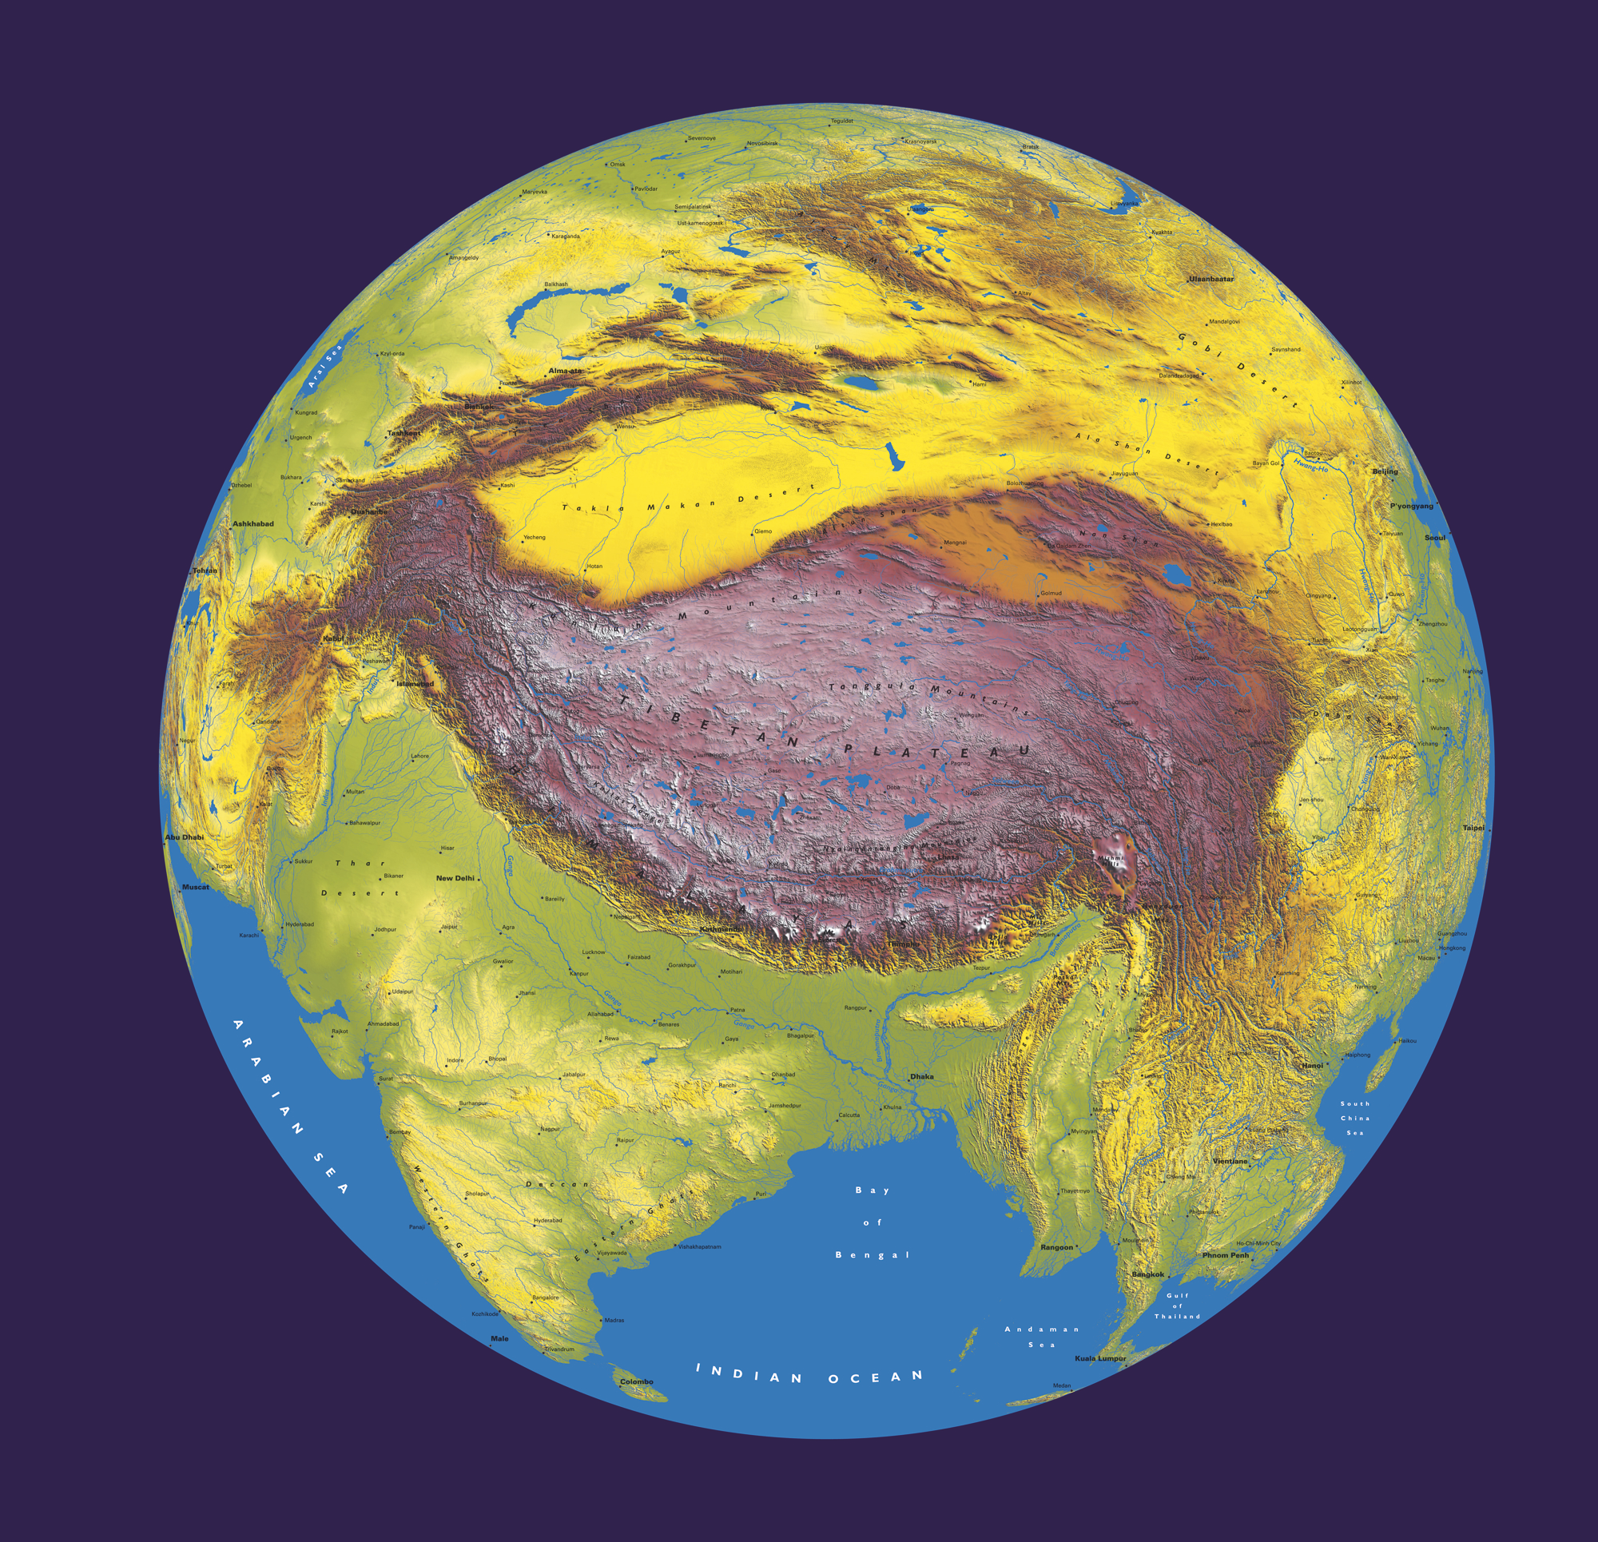
Research indicates on theTibetan Plateau the paleoecological research
glaciers will shrink so much in order to locate forest
That their melting borders will dry up And Savannah ecosystems
Profoundly affecting Which existed in Eemian Interglacial period
The Salween, MeKong, Huang-Ho When temperatures were
Brahmaputra, Yangtze, Ganges Similar to those predicted in the near future
And Indus River systems And thereafter
That traverse inner Mongolia, to search to locate local similar
China, Tibet, Autonomous-zone India ecosystems that Exist in our now
Burma, Laos, Cambodia, South Vietnam, And to begin designing and in part
Bangladesh, Kashmir and Pakistan Creating the process to Assist the
A Force Majeure has come into being Migration of a palette of species
In the form of global warming Able to replace or restate
That will work to the disadvantage Those now coming under Extreme stress
Of 1/16th of the earth’s population Thereby Generating new forest
Or about 1.2 billion people And grassland
Who live in the 7 drain Basins which will in good part replace
That comprise over The slow water releasing
2.4 million square miles Properties of glaciers
and snowmelt by in part creating
Thus we make an unlikely proposal a 2 million square kilometer sponge
in this highly stressed probable future To normalize rivers
by generating and secure the lands from flood and drought

From Sierra Nevada: An Adaptation (installation)- A Force Majeure work
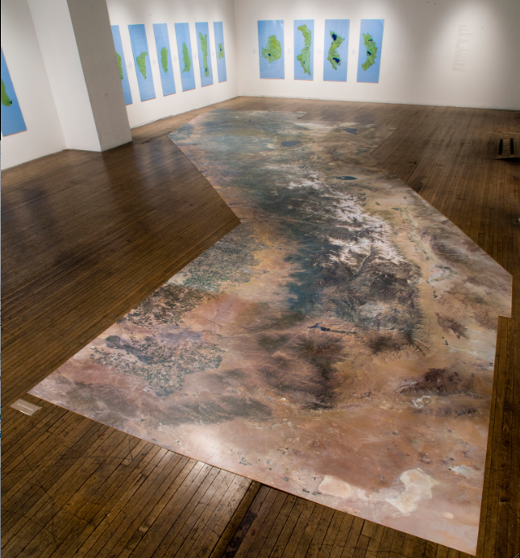
Installation Ronald Feldman Gallery, in collaboration with the Nevada Museum of Art. A 44 foot long floor work basically done with hi resolution satellite photography, the floor piece accompanied by 16 watershed drawings of the major watersheds coming from the ridgelines all together give the viewer the sense of the magnitude of the range of the Sierra Nevada. It takes approximately seven 6 foot paces to traverse the work in the gallery creating a metaphor for walking the Sierras. The detail is such that people can on their hands and knees find places they have been and become aware of the vast logging operations.
Sierra Nevada Project Definition: A Draft Experimental Design
The Project is designed to field test in a formal research setting core concepts that the Harrison Studio has been working with for the past 35 years. The Project will be designed to answer the following question: Are there ecologically available responses that will, in good part, replace the value once provided by disappearing glaciers and snow pack to river systems and the human and ecological cultures they support?
The methodology to find an initial set of probable answers to these and related questions at a manageable scale will include:
- Establishing a transect from the highest useful point in the Sagehen watershed, dropping 2,300 ft. about a 5.5-mile span to the outfall of the Sagehen Creek into Stampede Reservoir. The transect (see modified Google map and topo drawing) is designed to touch all major ecotomes: meadow, riverine, forest types and shrublands.

- We estimate (subject to precise evaluation on the ground) that approximately 20 or more site variations will be found over the approximately 5-mile transect.

- On each site we identify, we will place two framing elements, either rope, wood or found materials on the ground. The shapes will enclose a total area the size of a football field, although shaped according to the nature of the site.

- We will leave one tract alone as a control. We will use the other as a test site for an aspect of the yet to be determined species palette. The species palette will be designed to accept warming, intermittent heavy rains and drought. It will be continually reevaluated over the research period for its capability to hold back erosion, enhance topsoil and to function in a fire-tolerant manner, above all, the intention is that such a palette will enhance the sponge dynamics in the earth in such a way that the earths, as far as possible, will hold and release the waters, once supplied by snow pack and glacial melt, to river and stream.

- As the artist lead, the Harrison Studio has received research monies to enable funding the team of scientists to begin this work.

- As the experiment begins to take place, we will establish on the 5-mile path through the site, an ongoing changing narrative, informed in good part by that which is discovered.

- The work as a whole will function as a complex hybrid form consisting of; a work of art, scientific experiment, a bio-regional proposal and an educational program. The physical work on the ground will have a strong presence and be associated with a lucid poetic narrative designed to evolve in response to new information. In addition to providing creative and educational connections with the museum and the community at large, it will also serve to train students.

From Sierra Nevada: An Adaptation: The Sagehen Watershed
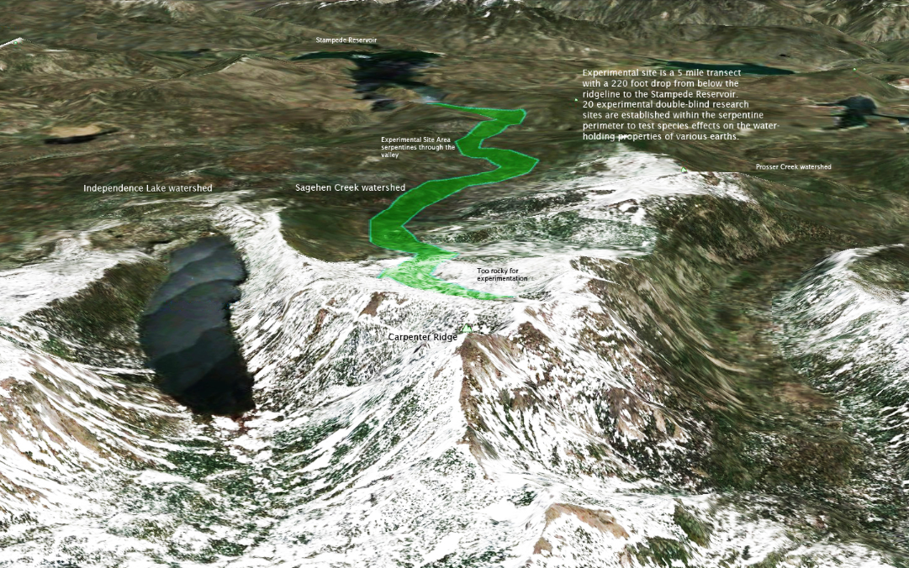
Trajectory of 20 double blind sites that will be used to test the concept and potentially value of designing species palettes that will respond favorably to the flood and drought expected in the high grounds as a result of rapid (forced) global warming. Species groupings will be selected to favor fire resistance, biodiversity, drought tolerance and the ability to sequester waters.

From Sierra Nevada: An Adaptation
Topographic Map: Sagehen Creek Watershed
Tentative site selections and tentative site for 100 meter deep core drilling.
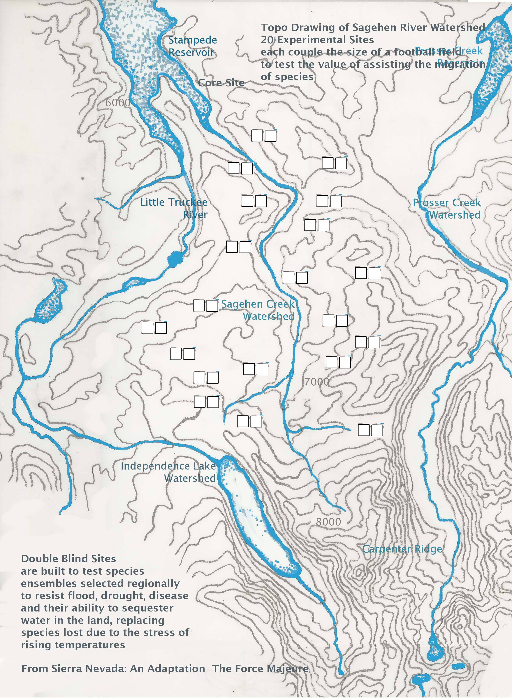
The core and depth is to discover species types and diversity from a paleoecological perspective and will be designed to reach the Eemian interglacial period 115,000-130,000 years ago when weather conditions were very similar to those predicted to prevail in the next 50-100 years.

Center for the Force Majeure

The Center for the Force Majeure Studies established on
the University California Santa Cruz campus has four primary missions.

- Botanical explorations and experimentations that will assist the migration of species upward to comepensate for species loss, flood and drought due to accelerated global warming in the high grounds particularly mountain areas. The Center will be examining the possibility of generating ecosystemic design directed toward adaptation at great scale
- The center expects to develop experimentation towards these ends working with the personnel at the University of California Berkeley research station located in the 8000 acre Sagehen Watershed.
- Generating a Paleobotanical Library with special emphasis placed on utilizing information gainded from the Eemian period in paleohistory approximately 115,000-130,000 years ago when the temparatures and weather conditions were similar to those predicted within the next 50-100 years particularly in the Sierra Nevadas
- A parallel form emerging as an activity of the center are ecological game structures based on the concepts embedded in or flowing from the ecological definition of the Force Majeure. The Center will be utilising the resources of the University which is one of the four prinicipal acadamic game generating institutions in the US.

